Date:12.03.2022

**Third Year B. Tech., Sem VI 2021-22**

**Software Engineering Tools Lab**

**Assignment Submission**

**PRN No: 2019BTECS00064**

**Full name: Kunal Santosh Kadam**

**Batch: T2**

**Assignment: 4**

**Title of assignment: Configuration Management Tools**

1. Differentiate **Chef Vs Puppet Vs Ansible Vs Saltstack** w.r.t properties given below.
2. Owner/ Company
3. Open/free/proprietary
4. Size
5. Configuration type(push/pull)
6. Components
7. Written in language
8. Tasks that can be performed (infrastructure/code management etc.)
9. Advantages
10. Disadvantages
11. Website
12. Installation prerequisite

Ans:

|  |  |  |  |  |
| --- | --- | --- | --- | --- |
| Properties | Chef | Puppet | Ansible | Saltstack |
| Owner/Company | Produced by Progress Chef and founded by Adam Jacob | Produced by Puppet and founded by Luke Kanies | Written by Michael DeHaan and acquired by Red Hat | Developed by Thomas S Hatch |
| Open/free/proprietary | Open-Source Software | Open-Source Software | Open-Source Software | Open-Source Software |
| Size | 0.08 MB | 0.08 MB | 0.08 MB | 0.08 Mb |
| Configuration Type(push/pull) | Supports Pull Configuration | Supports Pull Configuration | Supports Push Configuration | Supports Push Configuration |
| Components | Nodes, Workstations, Knife, Repository, Cookbooks | Puppet Master, Puppet Agents, Configuration Repository, Facts, Catalog | Control Node, Managed Nodes, Inventory, Modules, Tasks, Playbooks | SaltMaster, SaltMinions, Execution, Formulas, Grains, Pillar, Top File, Runners, Returners, Reactor, SaltCloud, SaltSSH |
| Written in Language | Client: Ruby  Server: Ruby, Erlang | C++ & Clojure from 4.0, Ruby | Python, PowerShell, Shell, Ruby | Python |
| Tasks that can be performed (infrastructure/code management etc.) | Deployment task  In devops | Deployment task  In devops | Deployment task  In devops | Deployment task  In devops |
| Advantages | 1. Accelerating Software Delivery  2. Improving Risk Management  3. Managing both Data Center and Cloud Environments  4. Delivering all your Infrastructure- any app, everywhere, continuously | 1. Puppet is open source  2. Puppet allows resource abstraction  3. Puppet does a transaction only if needed  4. Puppet’s language is clean and easily learnable  5. Puppet has an active community | Ansible is an open-source tool  Very simple to set up and use  Ansible lets you model even highly complex IT workflows. | 1. Flexible  2. Python api  3. Parallel execution |
| Disadvantages | 1. Not good documentation  2. Not easy to learn if you don’t know ruby | 1. Not good documentation  2. Not easy to learn if you don’t know ruby  3. Not suitable for small businesses | 1. Insufficient UI  2. Limited windows Support  3. Not have experience | Not good UI |
| Website | [www.chef.io](http://www.chef.io) | [www.puppet.com](http://www.puppet.com) | [www.ansible.com](http://www.ansible.com) | [www.saltproject.io](http://www.saltproject.io) |
| Installation prerequisite | 4 GB RAM | 4 GB RAM | 4 GB RAM | 1. GB RAM |

1. What are the different flavours of **Chef configuration management tool**?

Ans:

Chef comes in various flavors, such as Chef Solo, which has no remote server and cookbooks are located on the local site itself

There’s also Hosted Chef, where a Chef server is provided as a service on the cloud. Thus, there is no need to set up a server yourself.

If you want traditional Chef architecture, there’s Chef Client/Server. With this flavor, a hosted remote server communicates between the workstation and node.

Finally, there is a Private Chef, which is the enterprise version of Chef. With this flavor, the server is hosted within the enterprise infrastructure.

1. What is **Pull and Push** configuration?

Ans:

Configuration management is process of tracking and controlling the changes in a software with respect to its requirement, design, function, and development of a product.

There are two types of configuration management approaches

1. Pull Model:

In this type of configuration management tool, the nodes pull the configuration information from the server.

A small software (called agent or client) is installed on every node. This agent/client will:

* at regular intervals, get the configuration from the server
* compare the configuration received from the server with the current configuration of the node
* if there is any mis-match, take the steps required to match the configuration of the node with the configuration received from the server.

This means that, its always the agent/client that initiates communication, not the main server.

Chef & Puppet are good examples of such configuration management tools.

1. Push Model:

* In this type of configuration management tool, the main server (where the configuration data is stored) pushes the configuration to the node.
* So, it is the main server that initiates communication, not the nodes. Which means that an agent/client may or may not be installed on each node.
* Ansible is an example of a push based configuration management tool that doesn’t need an agent to be installed on the nodes.
* SaltStack is an example of a push based configuration management tool that needs an agent (minion) to be installed on the nodes.
* In both cases, its the main server that starts the communication and sends the configuration data to the nodes without the nodes asking for it.

1. What is **Playbook and Inventory w.r.t Ansible** and **recipe and cookbook w.r.t Chef** configuration management tool?

Ans:

Playbook and Inventory in Ansible

1. Playbook:

* A playbook is a set of configuration management scripts that define how tasks are to be executed on remote hosts or a group of host machines. The scripts or instructions are written in YAML format.
* For instance, you can have a playbook file to install the Apache webserver on CentOS 7 and call it httpd.yml.
* To create the playbook run the command:



* A YAML file begins with 3 hyphens. Inside the file, add following instructions.

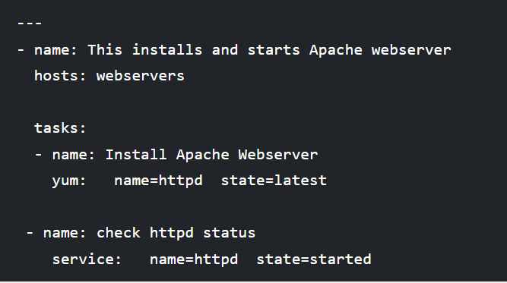

* The above playbook installs Apache web server on remote systems defined as webservers in the inventory file. After the installation of the webserver, Ansible later checks if the Apache web server is started and running.

1. Inventory:

* An inventory is a text file that contains a list of servers or nodes that you are managing and configuring. Usually, the servers are listed based on their hostnames or IP addresses.
* An inventory file can contain remote systems defined by their IP addresses as shown:

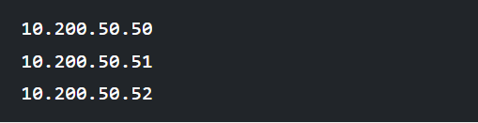

* Alternatively, they can be listed according to groups. In the example below, we have servers placed under 2 groups – web servers and databases. This way they can be referenced according to their group names and not their IP addresses. This further simplifies operation processes.

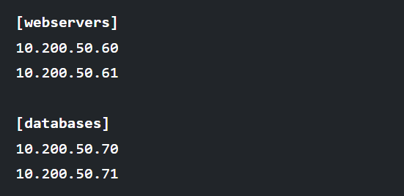

1. Perform below operations on your machine to check **working of Ansible**.
2. Install Ansible
3. Setup an Inventory
4. Create a playbook to install MySQL db on one node.
5. Execute a playbook

Ans:

Steps to execute installation of ansible:

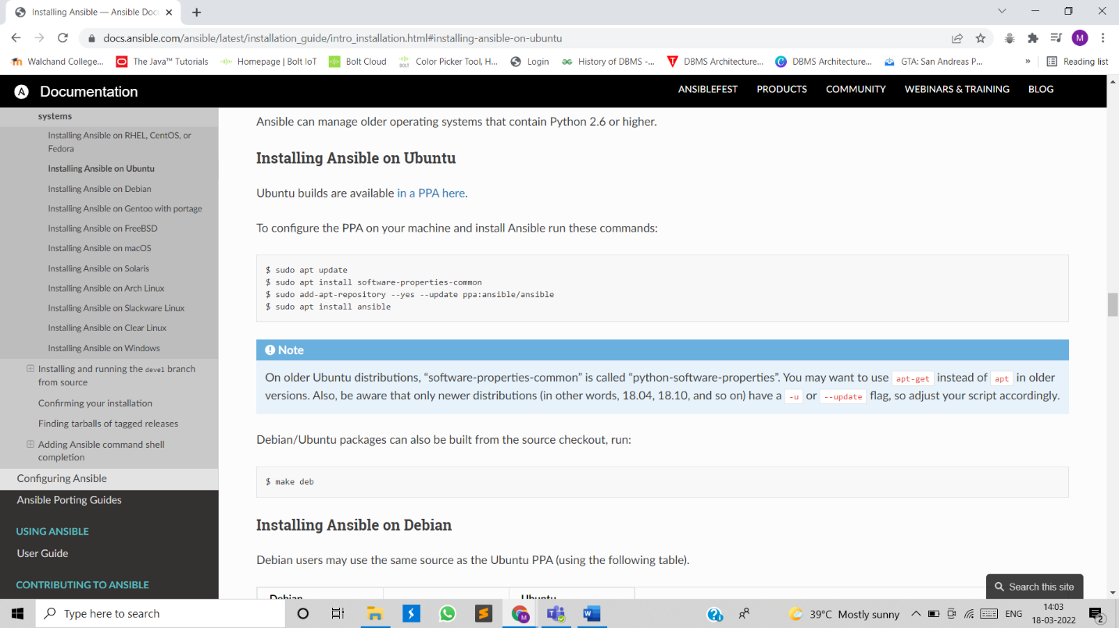

Updating the existing packages:

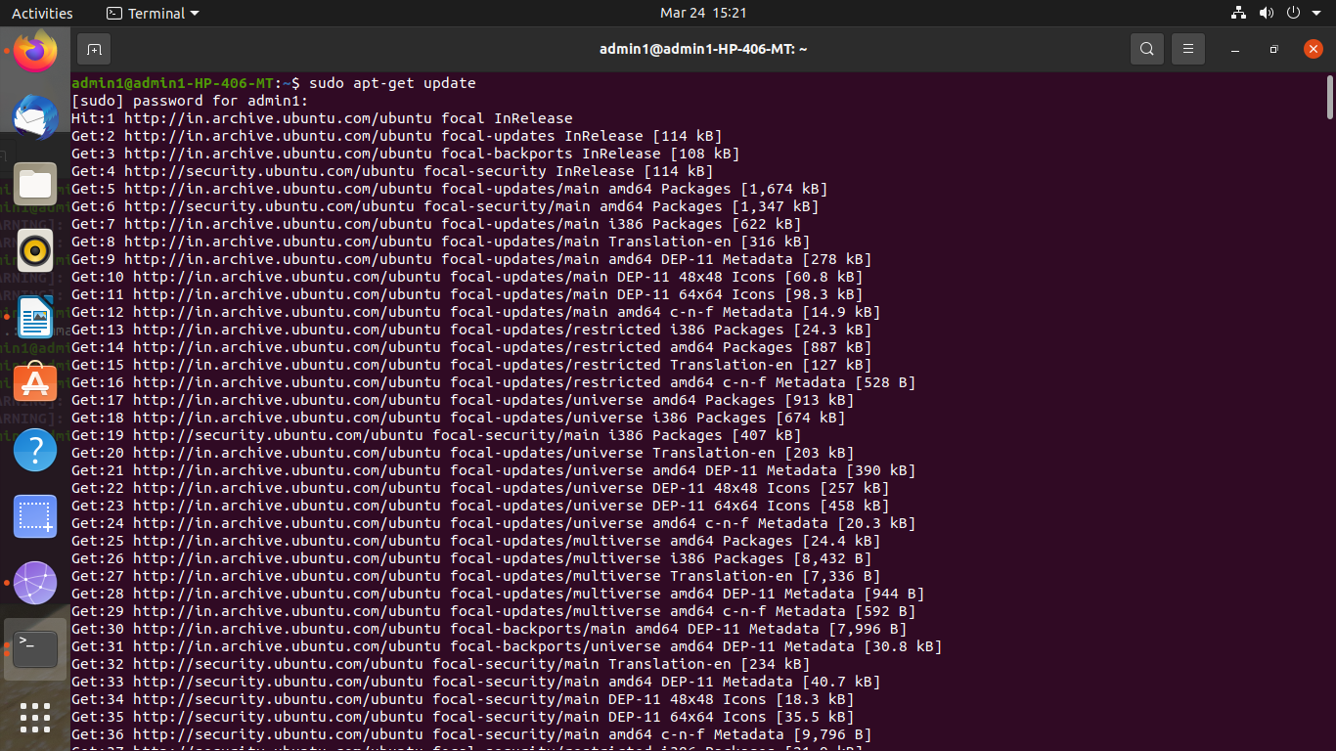

Executed above command to install ansible:

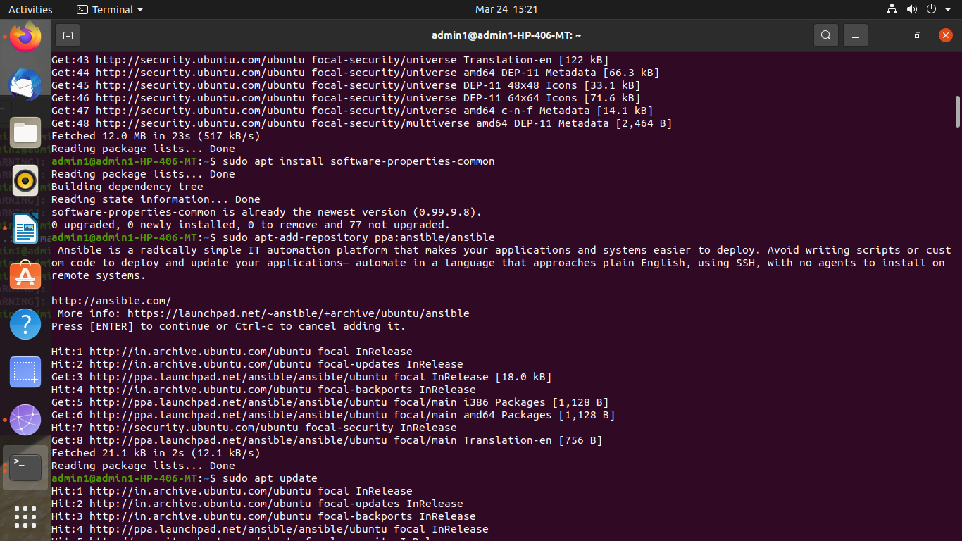

Installation of ssh

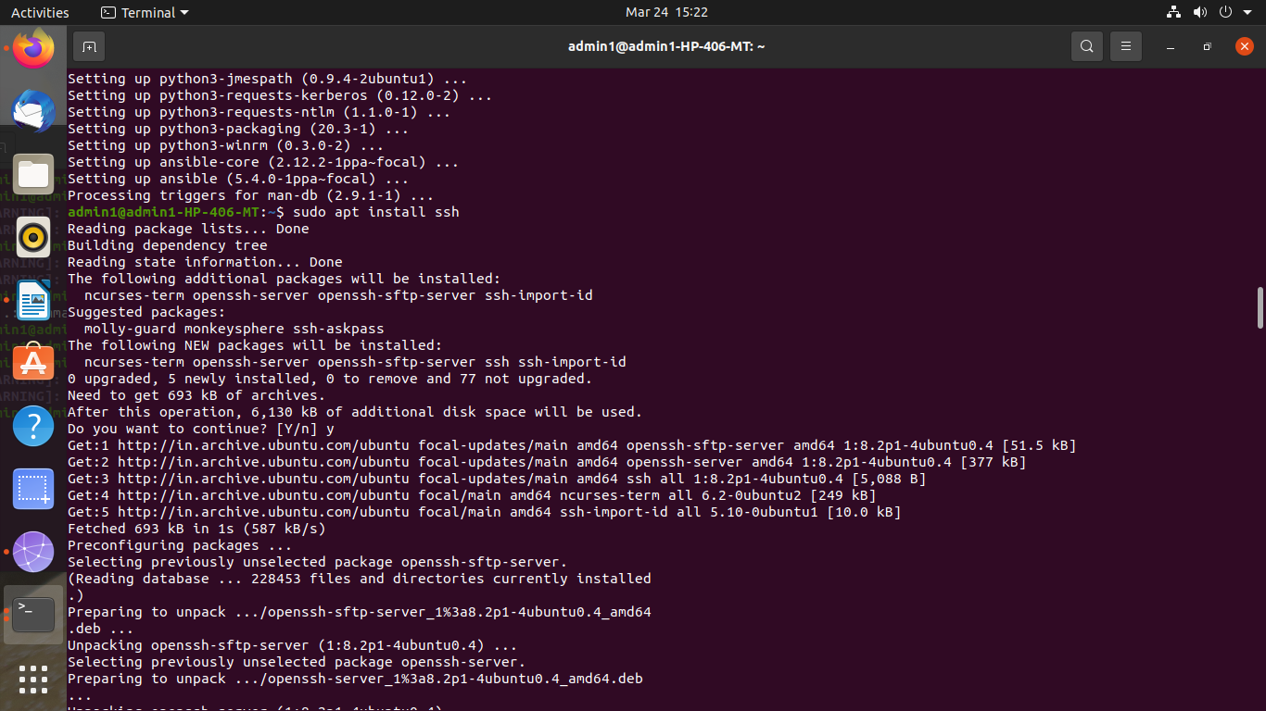

Editing host inventory file, added IP address of working node

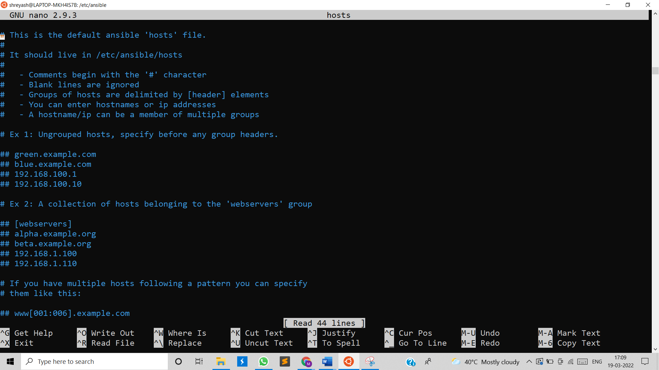

Testing connection with working node

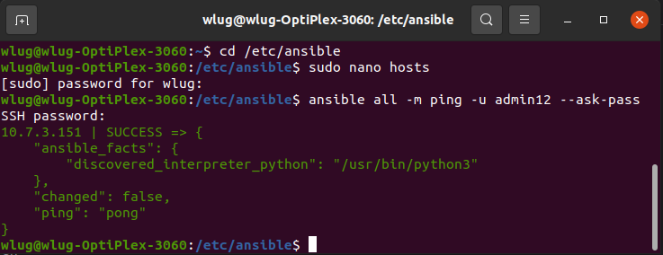

Creating playbook named test.yml file to install MySQL server on that node.

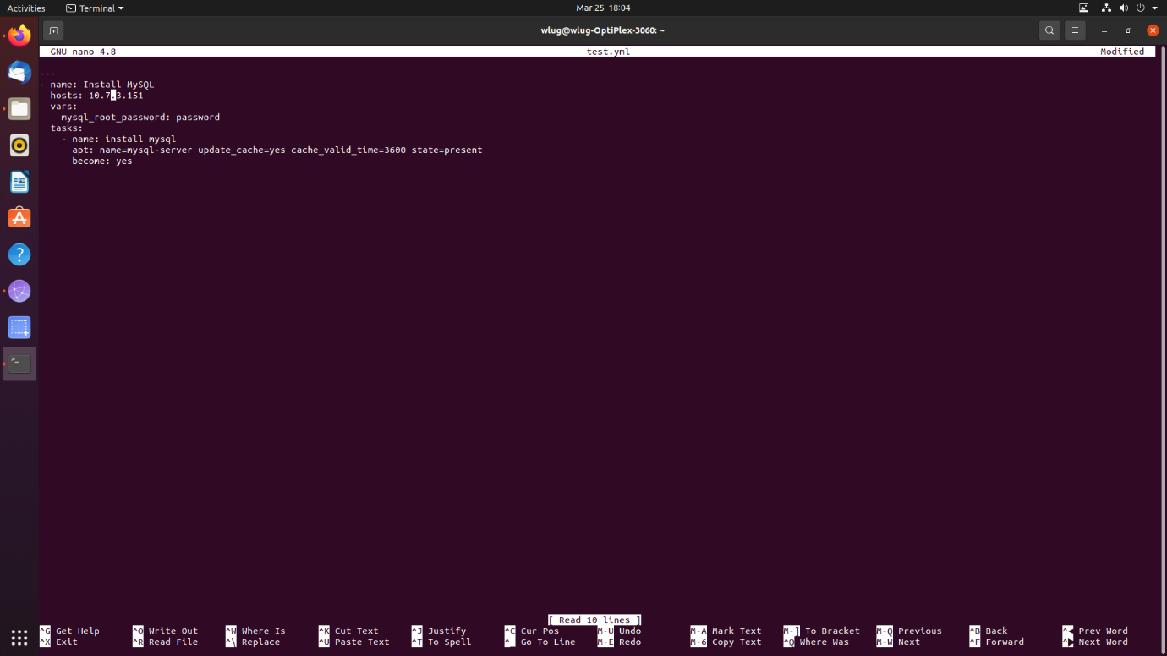

Executed test.yml file for installation.

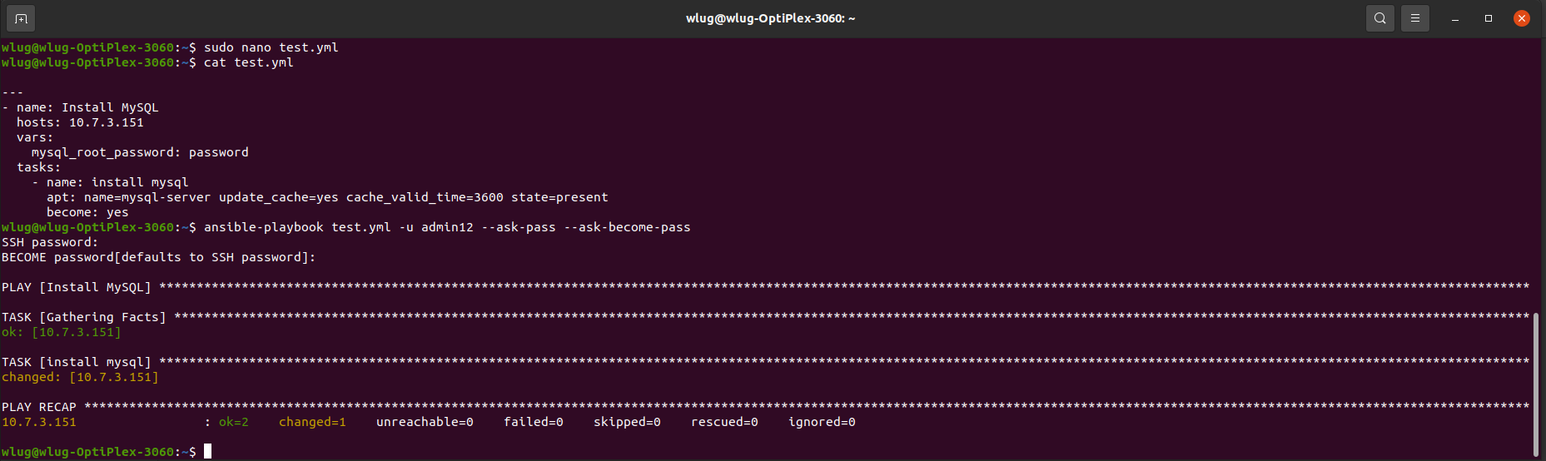

Tested whether the MySQL server installed on node:

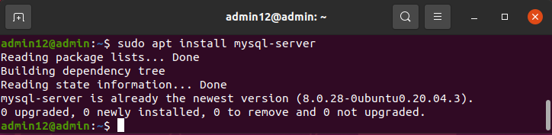

1. Perform below operations on your machine to check **working of Chef**.
   1. Install Chef
   2. Create a recipe and place it in a cookbook to install MySQL db on one node.
   3. Execute a recipe using knife command.

Ans:

1.Installation of chef-

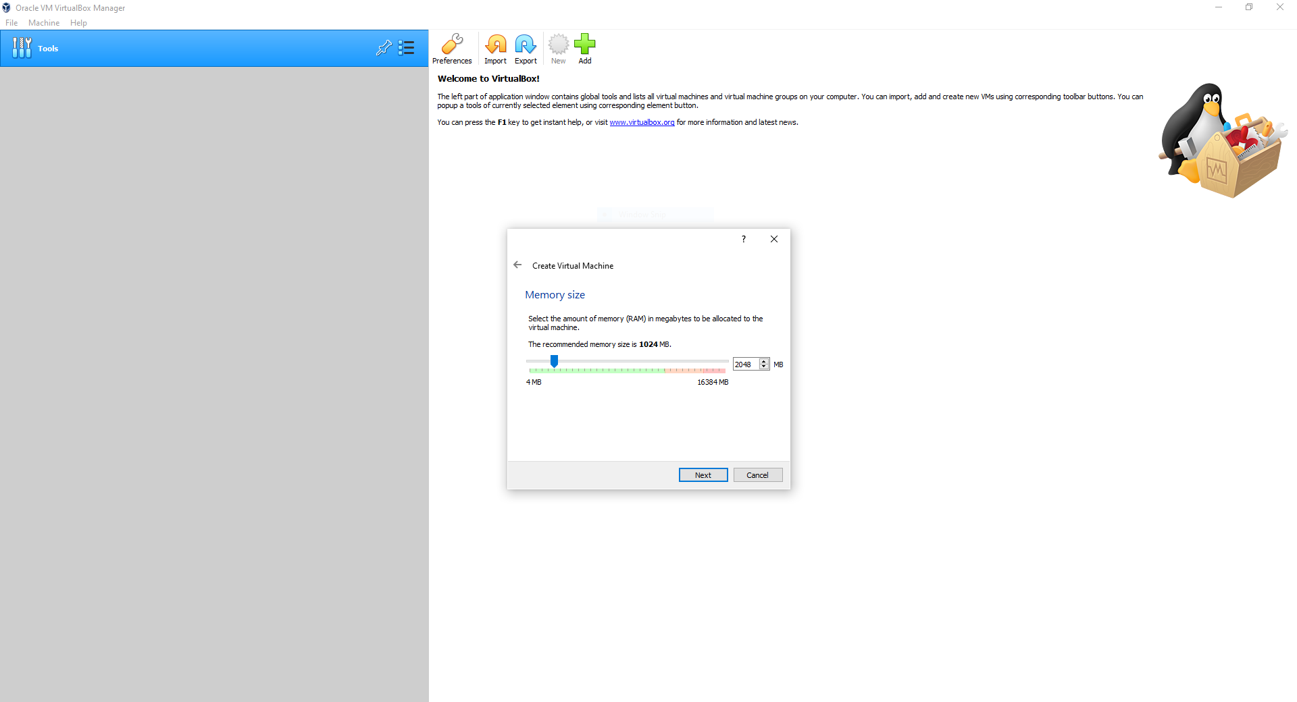

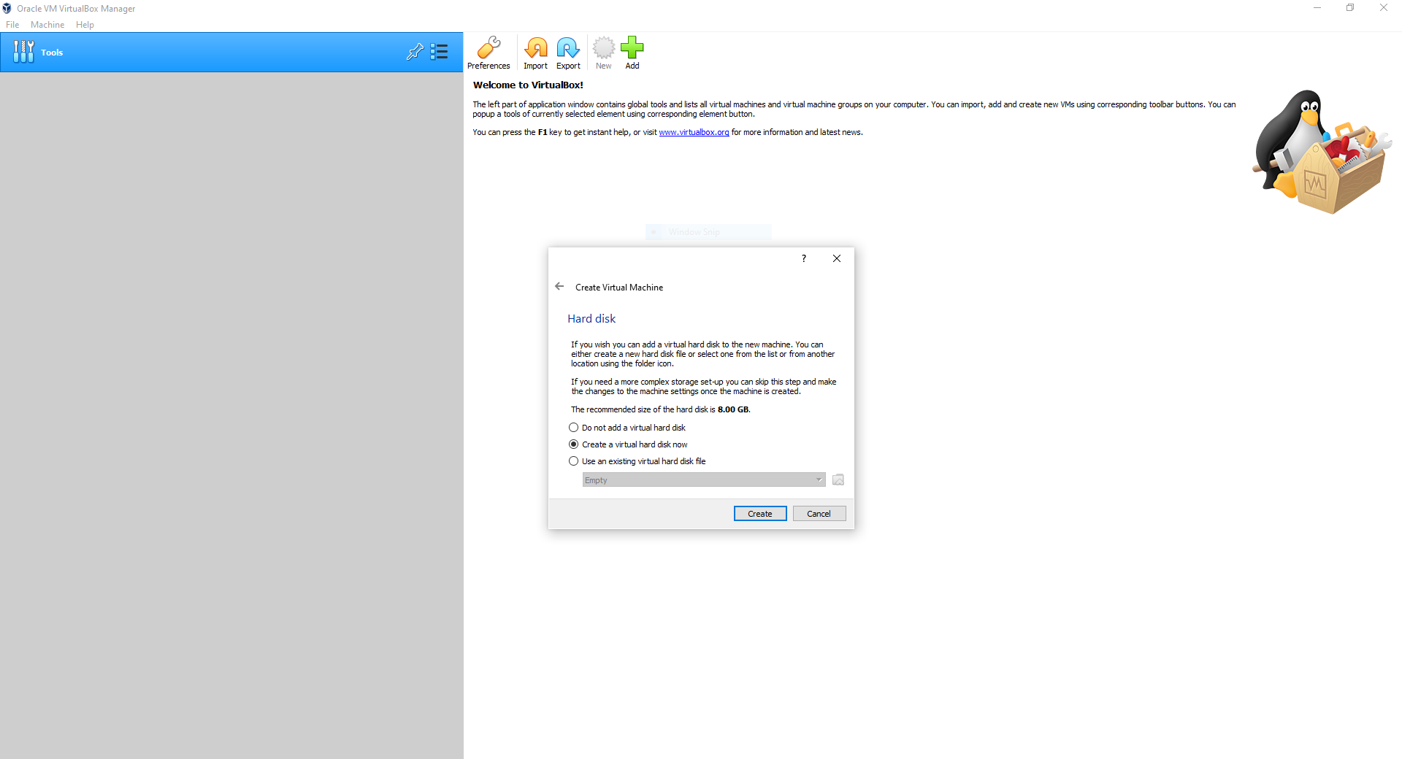

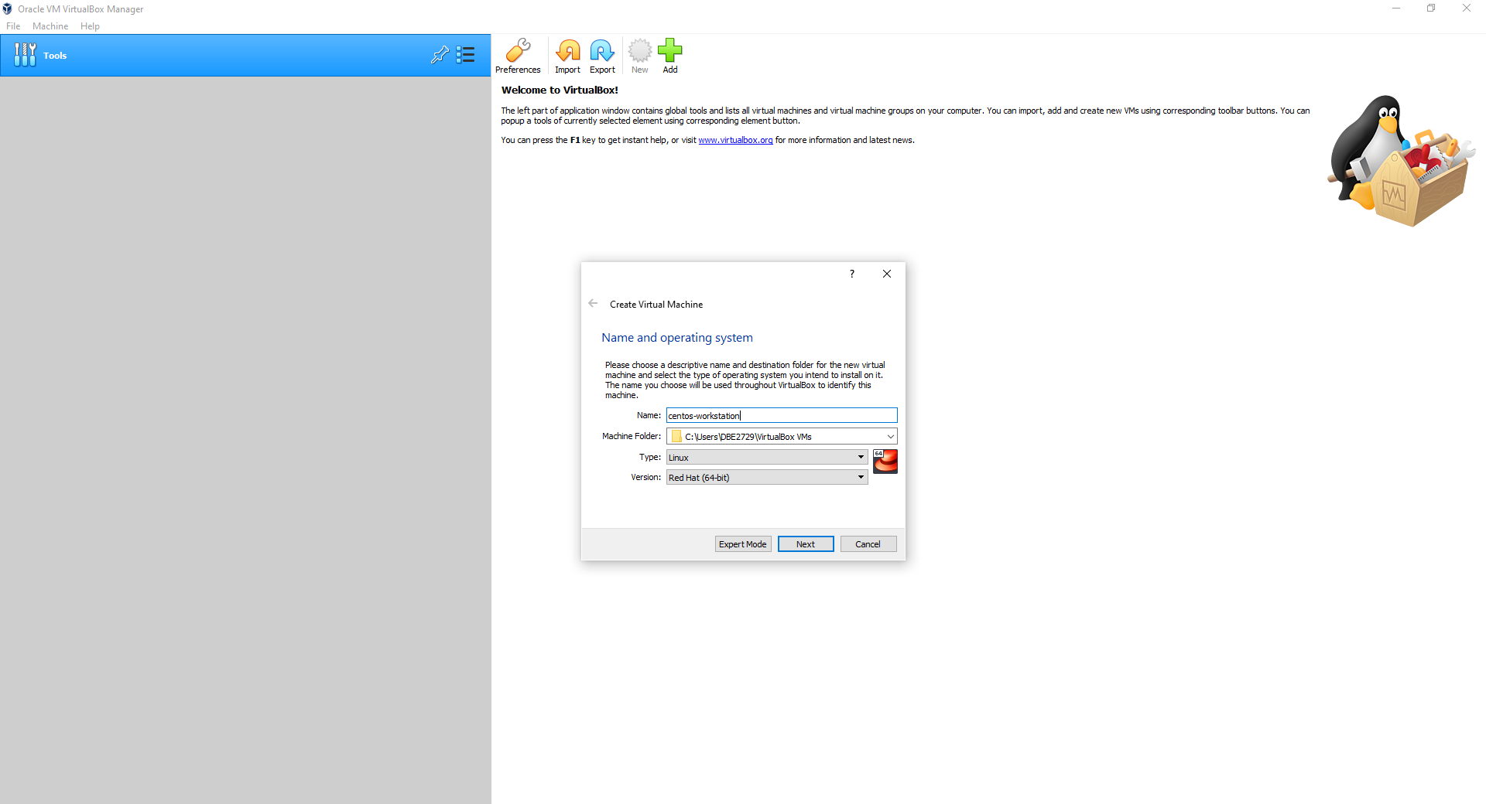

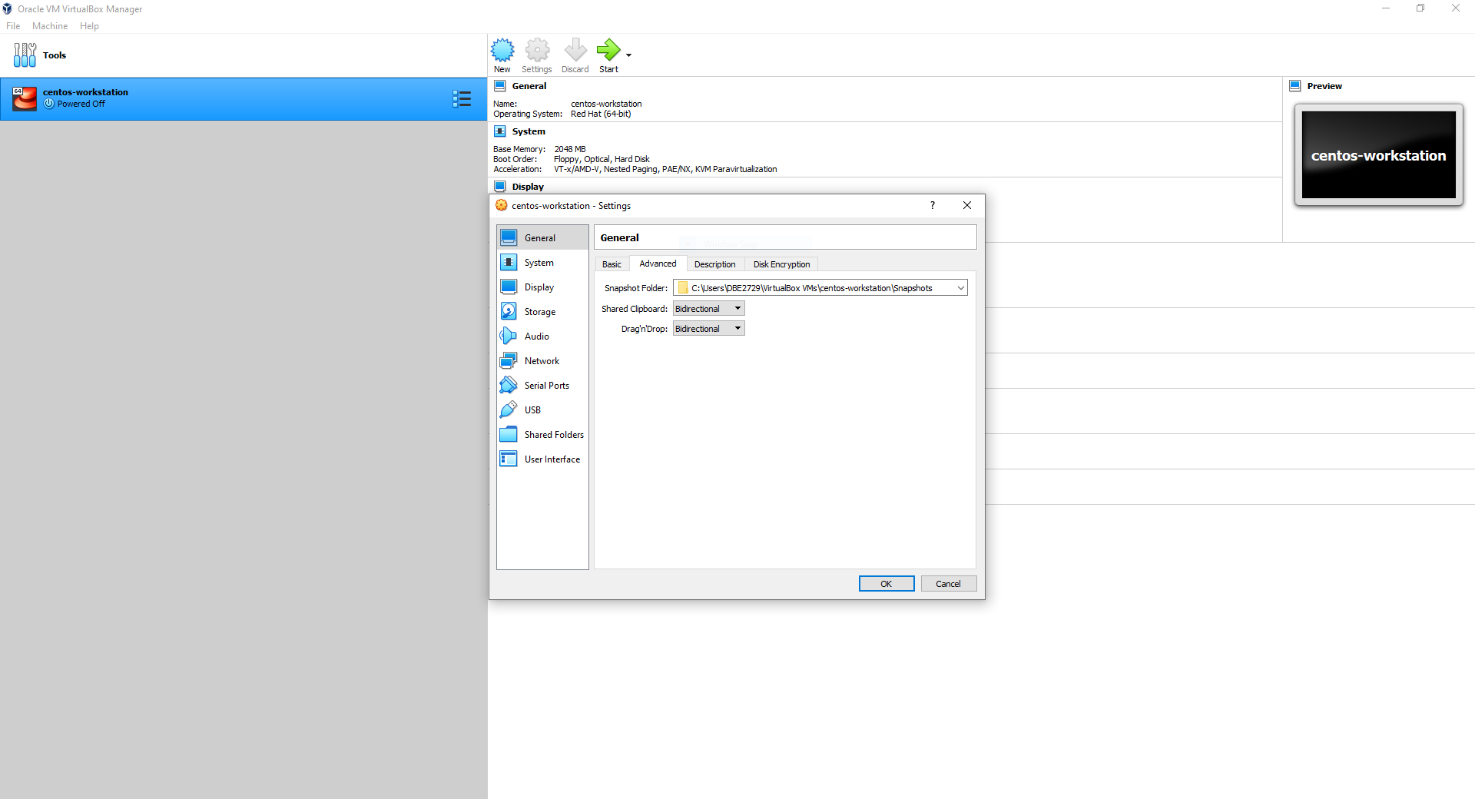

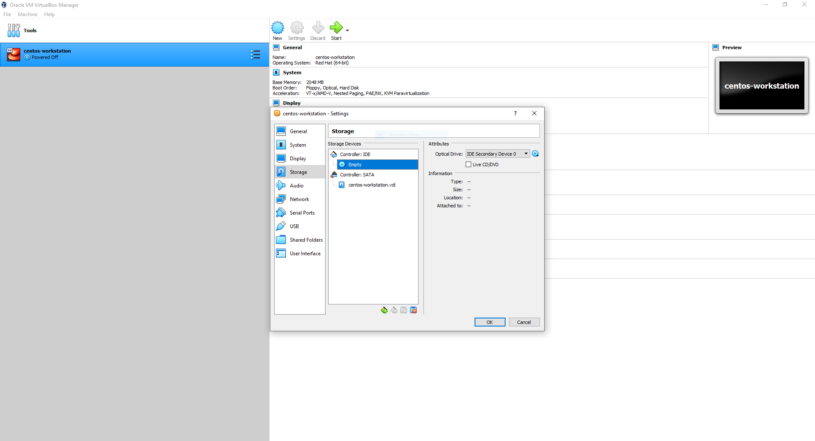

2. Creating a recipe and place it in a cookbook to install MySQL db on one node.

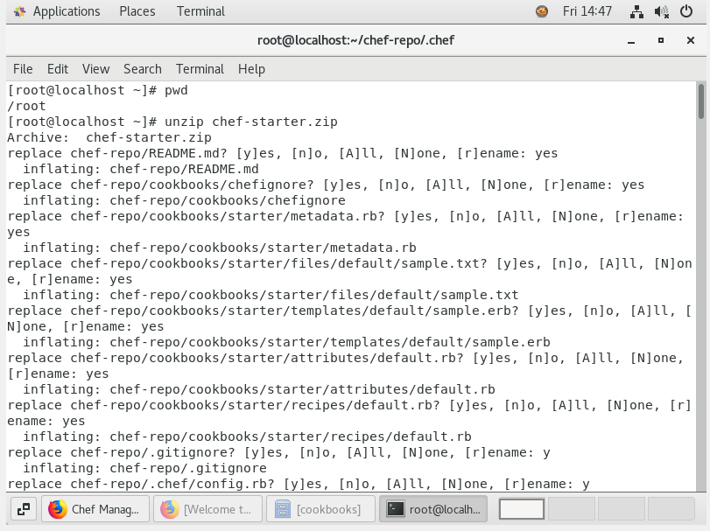

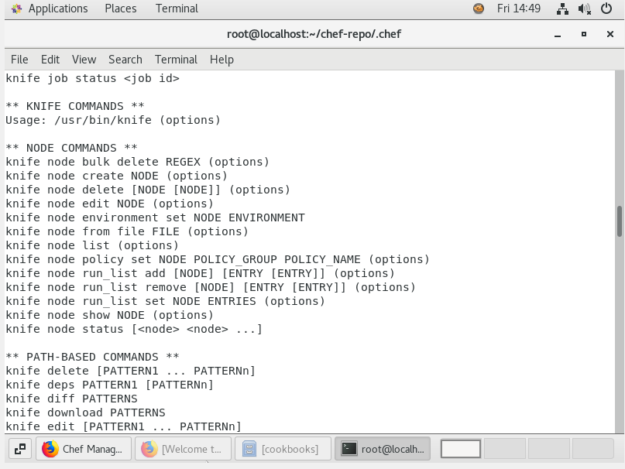

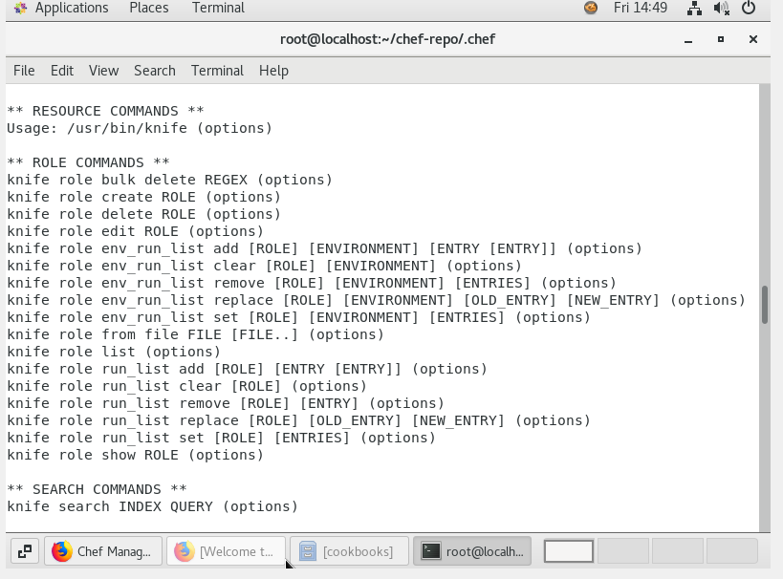

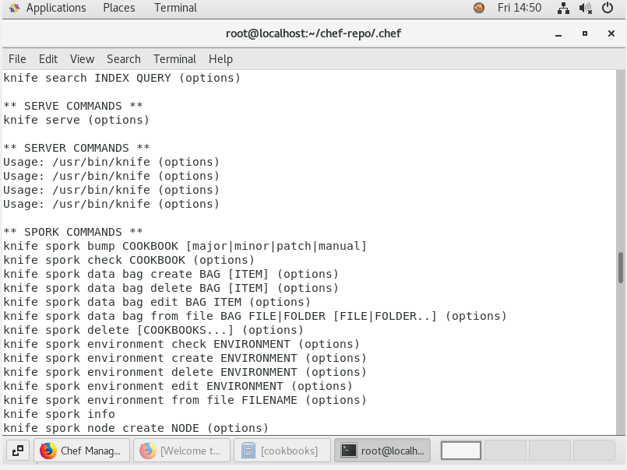

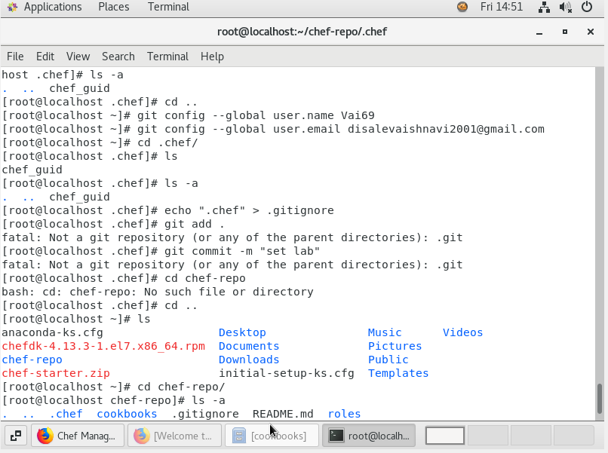

**3.** Executing a recipe using knife command.

